# Exercises: jQuery, DOM and Events

Problems for exercises and homework for the [“JavaScript Advanced” course @ SoftUni](https://softuni.bg/courses/javascript-advanced). Submit your solutions in the

## Increment Counter

You are tasked with creating a piece of **HTML** dynamically using JavaScript and **appending** it to a given element using a passed in **selector**.

### HTML and JavaScript Code

You are given the following **HTML** code:

|  |
| --- |
| incrementCounter.html |
| <!DOCTYPE **html**> <**html lang="en"**> <**head**>  <**meta charset="UTF-8"**>  <**title**>Increment Counter</**title**>  <**script src="https://code.jquery.com/jquery-3.1.0.min.js"  integrity="sha256-cCueBR6CsyA4/9szpPfrX3s49M9vUU5BgtiJj06wt/s="  crossorigin="anonymous"**></**script**> </**head**> <**body**>  <**div id="wrapper"**>  </**div**>  <**script src="incrementCounter.js"**></**script**>  <**script**>  **window**.onload = **function**(){  *increment*(**"#wrapper"**);  }  </**script**> </**body**> </**html**> |

It comes together with the following **JavaScript** code:

|  |
| --- |
| incrementCounter.js |
| **function** *increment*() {  *//* ***TODO*** } |

Your function will receive a **string** value representing a **selector** (for example "#wrapper" or ".root"), all elements created should be appended to the **selector**.

The HTML you create should contain 4 elements:

* <textarea> with class="counter", value="0" and the disabled attribute.
* <button> with class="btn", id="incrementBtn" and text "**Increment**".
* <button> with class="btn", id="addBtn" and text "**Add**".
* Unordered list <ul> with class="results".

When the [Increment] is clicked the value of the **textarea** should go up by **one** (if it was 0 it should become 1 e.t.c.). When the [Add] is clicked a new list item (<li>) with text equal to the current value of the textarea should be added to the unordered list.

Submit in the judge the JS code (implementation) of the above function. It may hold other functions in its body.

### Screenshots

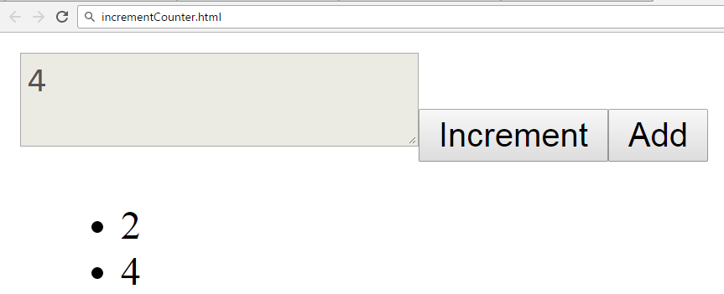

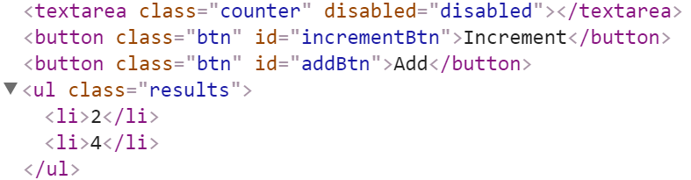

### Hints

We’ll start off by creating the needed elements and parsing the **selector**, we can do it easily with **jQuery** like this:

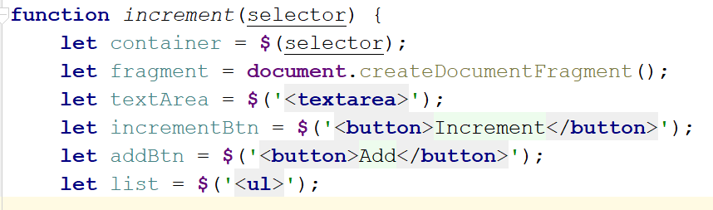

Adding multiple elements to the DOM can be expensive, instead of repeatedly adding to the DOM we can create a DocumentFragment and **add** the elements to it instead. When we have built our hierarchy we can **append the** DocumentFragment to the DOM, which will add all of the fragment’s elements to the specified selector.  
  
The next step is to **add values**, and **attributes** to the **elements** and **events** to the **buttons**:

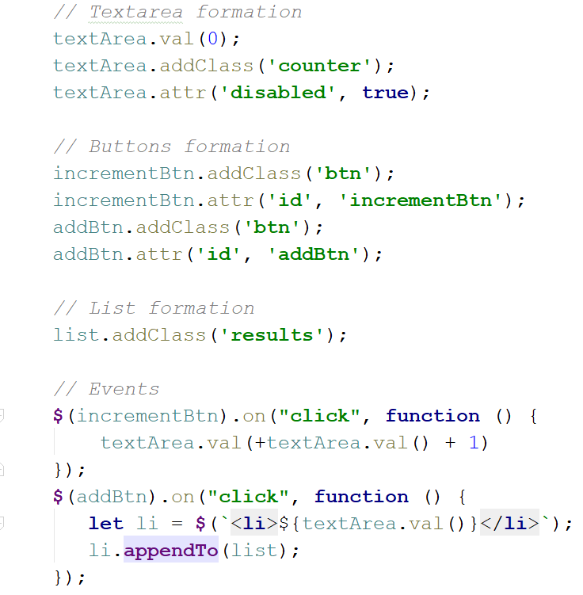

The last step is to **add** our elements to the DOM:

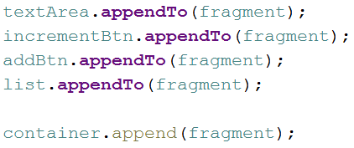

Our code is now ready to be submitted to Judge.

## Timer

You will be given an **HTML** file, containing the markup of a **timer** with spans for **seconds**, **minutes** and **hours** and buttons to [Start] and [Pause] the timer. Your task is to create a JavaScript application that **starts** the timer whenever the [Start] button is pressed and **pauses** it when the [Pause] button is pressed.

### HTML and JavaScript Code

You are given the following **HTML** code:

|  |
| --- |
| timer.html |
| <!DOCTYPE **html**> <**html lang="en"**> <**head**>  <**meta charset="UTF-8"**>  <**title**>Timer</**title**>  <**script src="https://code.jquery.com/jquery-3.1.0.min.js"  integrity="sha256-cCueBR6CsyA4/9szpPfrX3s49M9vUU5BgtiJj06wt/s="  crossorigin="anonymous"**></**script**>  <**style**>  **#timer** {  **font-size**: 5**em**;  }  </**style**> </**head**> <**body**> <**div id="timer"**>  <**span id="hours" class="timer"**>00</**span**>:  <**span id="minutes" class="timer"**>00</**span**>:  <**span id="seconds" class="timer"**>00</**span**>  <**button id="start-timer"**>Start</**button**>  <**button id="stop-timer"**>Stop</**button**> </**div**> <**script src="timer.js"**></**script**> <**script**>  **window**.onload=**function**(){  *timer*();  } </**script**> </**body**> </**html**> |

It comes together with the following **JavaScript** code:

|  |
| --- |
| timer.js |
| **function** *timer*() {  *//* ***TODO*** } |

Submit in the judge the JS code (implementation) of the above function. It may hold other functions in its body.

### Constraints

* The initial value of the timer must always be **00:00:00**

### Hints

Note the spans have unique id values – we can use these to select and modify the elements with **jQuery**.

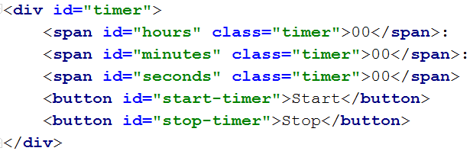

JavaScript has a built-in function setInterval() for executing and repeating an action after a set period of time. It returns an object which can later be used to stop the execution with clearInterval().

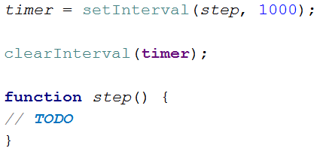

The **first argument** can be an inline declaration or a **named function**. The **second argument** is the **time interval**, specified in **milliseconds**. We can easily attach these two functions to the click event of a button.

To get and set the text of a markup element you can either use its textContent property, or jQuery’s text() function.

Keep in mind that that you should only have one setInterval() function active when the the timer is working, multiple presses of the [Start] button should not attach more setInterval() functions as that would break the correct operation of the timer.

## Book Generator

Create a function that accepts a selector, a title, an author and an ISBN and **uses** them to **create** the **HTML code** for a **book** and **inserts it** into the **selector**.

### HTML and JavaScript Code

You are given the following **HTML** code:

|  |
| --- |
| book-generator.html |
| <!DOCTYPE **html**> <**html lang="en"**> <**head**>  <**meta charset="UTF-8"**>  <**title**>Book Generator</**title**>  <**script src="https://code.jquery.com/jquery-3.1.0.min.js"  integrity="sha256-cCueBR6CsyA4/9szpPfrX3s49M9vUU5BgtiJj06wt/s="  crossorigin="anonymous"**></**script**> </**head**> <**body**> <**div id="wrapper"**>  </**div**> <**script src="book-generator.js"**></**script**> <**script**>  window.onload = **function** () {  *createBook*(**"#wrapper"**, **"Alice in Wonderland"**, **"Lewis Carroll"**, 1111);  } </**script**> </**body**> </**html**> |

It comes together with the following **JavaScript** code:

|  |
| --- |
| book-generator.js |
| **function** *createBook*() {  *//* ***TODO*** } |

Your function will receive **4 parameters** - a **string value** representing a selector (for example "#wrapper" or ".root"), a **string value** representing the titleof the book, a **string value** representing the authorof the book and a **number** representing the ISBN of the book. **After** the book is **created** it should be **attached** to the passed in **selector**.

The **number** in the Id of the containing div should be **incremented** by **one** **for each successive book created** (i.e. first book should have id = "book1", second id = "book2" and so on…). The title, author and ISBN should be **paragraphs** with a class equal to their **respective role** - class="title" for the **title paragraph**, class="author" for the **author paragraph** and class="isbn" for the **ISBN paragraph**. A book should also contain **2 buttons** – [Select] and [Deselect], when the [Select] button is pressed the border of the div element should be set to "2px solid blue". When the [Deselect] button is pressed it should be set to "none".

### Screenshots

The HTML code for a book should have the following structure:

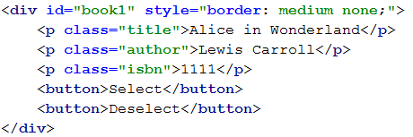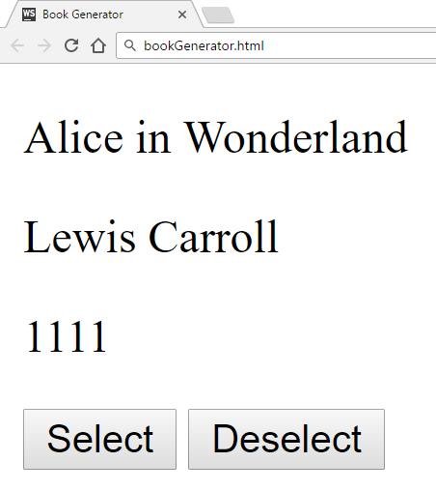

Selected book:

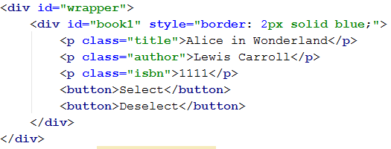

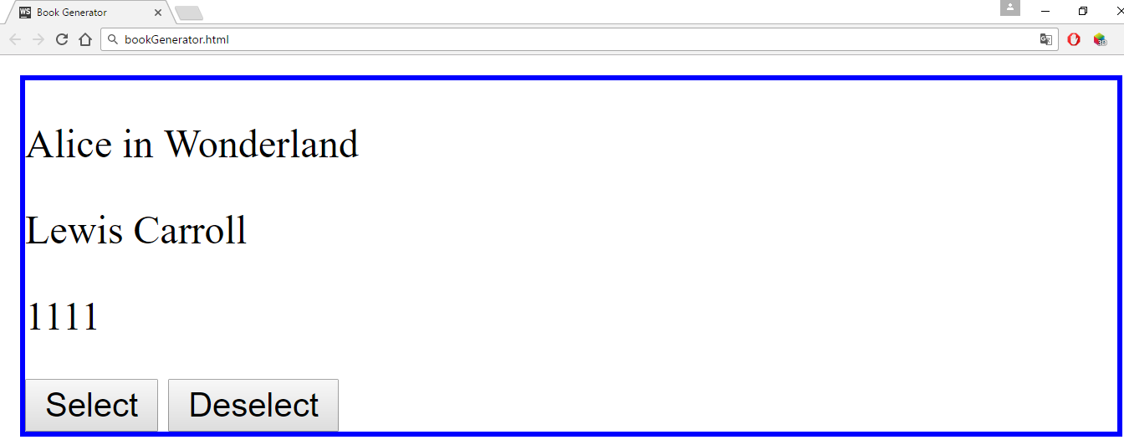

### Hints

You can use what is known as an **IIFE** (Immediately Invoked Function Expression) to declare and instantly execute a function that will keep the id variable in its scope. This way you will receive the inner function and for it the variable id will be **shared between all calls**, essentially becoming like a **static variable** for the function:

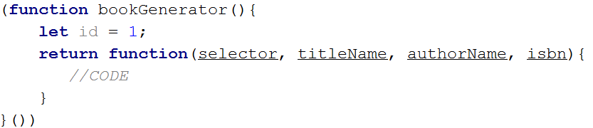

An **element’s** **css properties** can easily be changed with **jQuery** in the following way:



## Form Validation

You are given the task to write **validation** for the fields of a simple form.

### HTML and JavaScript Code

You are provided a **skeleton** containing the necessary files for your program.

The validations should be as follows:

* The username needs to be between **3** and **20** symbols **inclusively** and only **letters** and **numbers** are allowed.
* The password and confirm-password must be between **5** and **15** **inclusively** symbols and only **word characters** are allowed (**letters**, **numbers** and **_**).
* The **inputs** of the password and confirm-password field **must match**.
* The email field must contain the “**@**” symbol and **at least one** "**.**"(**dot**) after it.

If the "Is company?" checkbox is checked, the CompanyInfo fieldset should become **visible** and the Company Number field must also be **validated**, if it isn’t checked the Company fieldset should have the style "display: none;" and the **value** of the Company Number field shouldn’t matter.

* The Company Number field must be a number between **1000** and **9999**.

Every field with an **incorrect** value when the [Submit] button is **pressed** should have the following style applied border-color: red;, alternatively if it’s correct it should have style border: none;. If there are **required fields** with an incorrect value when the [Submit] button is pressed, the div with id="valid" should become **hidden** (**"**display: none;"), **alternatively** if all fields are correct the div should become **visible**.

### Constraints

* **You are NOT allowed to change the HTML or CSS files provided.**

### Screenshots

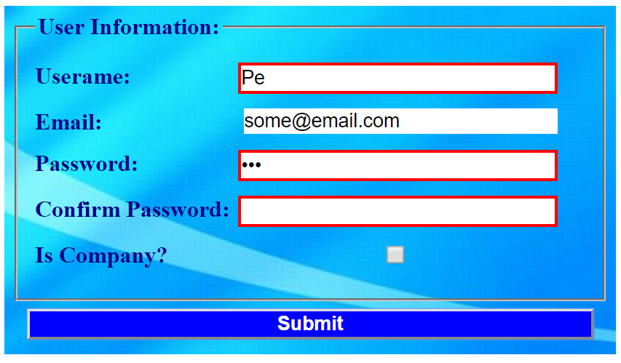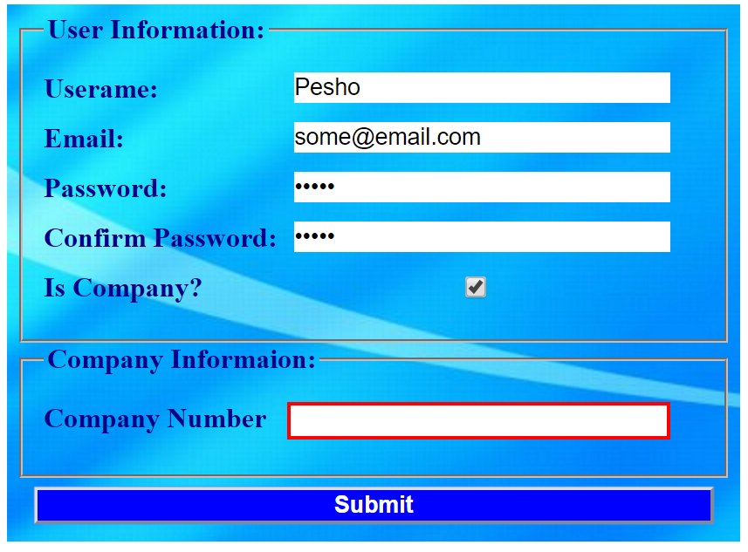

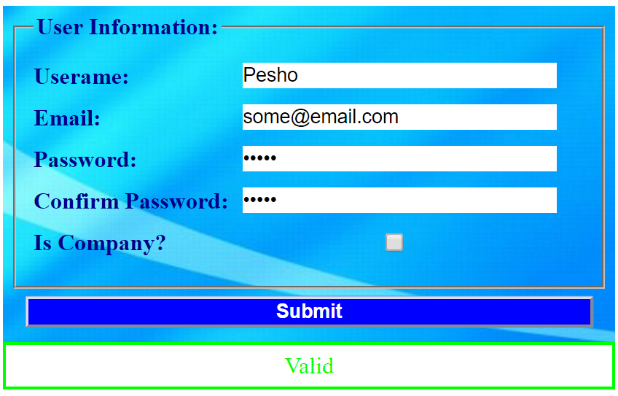

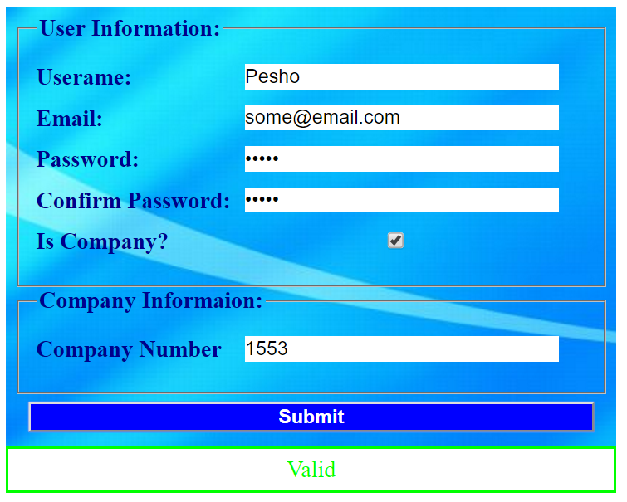

### Hints

* Use addEventListener() or jQuery’s on() function to **attach** an **event listener** for the "change" event to the **checkbox**.
* All buttons within a <form> automatically work as **submit** buttons, unless their type is **manually** **assigned** to something else, in order to avoid **reloading** **the page** upon **clicking** the [Submit] button you can add the following code in the function that handles the on click event: